The initial multiple regression model with GPA as our response, and HSGPA, SATV, SATM, and Male as our predictors, is overall decent at predicting the response, since it achieved a p-value of roughly 0, a decent F-statistic of 17.77, and a fairly good adjusted R-squared of 23.53%. However, from the individual p-values, we see that only HSGPA and SATV demonstrate enough evidence for us to reject the null ($H_{0}:β_{i}=0$) in favor of the alternative ($H_{a}:β_{i}≠0$). In other words, we suspect that SATM and Male are not needed for our multiple regression model.

After excluding these 2 features from our model, and verifying an improvement in the model’s p-value, F-statistic, and adjusted R-squared, we conclude that the equation of our final model is: $y=0.635+0.498X_{1}+0.001X_{2}$, where $y$ is GPA, $X_{1}$ is HSGPA, and $X_{2}$ is SATV.

solution

library(readr)

## Warning: package 'readr' was built under R version 4.1.2

data <- read_csv("data.csv")

## Rows: 219 Columns: 10  
## ── Column specification ────────────────────────────────────────────────────────  
## Delimiter: ","  
## dbl (10): GPA, HSGPA, SATV, SATM, Male, HU, SS, FirstGen, White, CollegeBound  
##   
## ℹ Use `spec()` to retrieve the full column specification for this data.  
## ℹ Specify the column types or set `show_col_types = FALSE` to quiet this message.

attach(data)  
head(data)

## # A tibble: 6 × 10  
## GPA HSGPA SATV SATM Male HU SS FirstGen White CollegeBound  
## <dbl> <dbl> <dbl> <dbl> <dbl> <dbl> <dbl> <dbl> <dbl> <dbl>  
## 1 3.06 3.83 680 770 1 3 9 1 1 1  
## 2 4.15 4 740 720 0 9 3 0 1 1  
## 3 3.41 3.7 640 570 0 16 13 0 0 1  
## 4 3.21 3.51 740 700 0 22 0 0 1 1  
## 5 3.48 3.83 610 610 0 30.5 1.5 0 1 1  
## 6 2.95 3.25 600 570 0 18 3 0 1 1

model = lm(GPA ~ HSGPA + SATV + SATM + Male)  
summary(model)

##   
## Call:  
## lm(formula = GPA ~ HSGPA + SATV + SATM + Male)  
##   
## Residuals:  
## Min 1Q Median 3Q Max   
## -0.95975 -0.27713 0.05058 0.28319 0.89525   
##   
## Coefficients:  
## Estimate Std. Error t value Pr(>|t|)   
## (Intercept) 6.135e-01 3.283e-01 1.869 0.06301 .   
## HSGPA 5.069e-01 7.623e-02 6.650 2.4e-10 ***  
## SATV 1.174e-03 3.940e-04 2.979 0.00322 **   
## SATM -5.580e-06 4.626e-04 -0.012 0.99039   
## Male 5.534e-02 6.020e-02 0.919 0.35901   
## ---  
## Signif. codes: 0 '***' 0.001 '**' 0.01 '*' 0.05 '.' 0.1 ' ' 1  
##   
## Residual standard error: 0.407 on 214 degrees of freedom  
## Multiple R-squared: 0.2494, Adjusted R-squared: 0.2353   
## F-statistic: 17.77 on 4 and 214 DF, p-value: 1.298e-12

plot(data[c(1, 2, 3, 4, 5)])

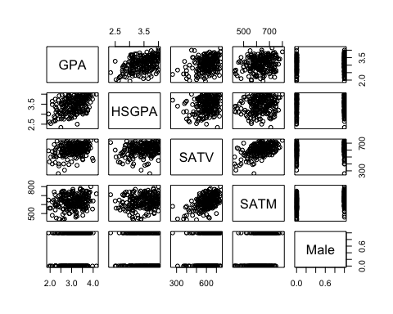

cor(data[c(1, 2, 3, 4, 5)])

## GPA HSGPA SATV SATM Male  
## GPA 1.00000000 0.44688735 0.3043114 0.1943439 0.05284917  
## HSGPA 0.44688735 1.00000000 0.2103212 0.1528396 -0.09031714  
## SATV 0.30431137 0.21032124 1.0000000 0.5269438 0.14555703  
## SATM 0.19434385 0.15283963 0.5269438 1.0000000 0.37099167  
## Male 0.05284917 -0.09031714 0.1455570 0.3709917 1.00000000

anova(model)

## Analysis of Variance Table  
##   
## Response: GPA  
## Df Sum Sq Mean Sq F value Pr(>F)   
## HSGPA 1 9.433 9.4329 56.9351 1.275e-12 ***  
## SATV 1 2.186 2.1861 13.1947 0.0003514 ***  
## SATM 1 0.019 0.0193 0.1165 0.7331979   
## Male 1 0.140 0.1400 0.8450 0.3590096   
## Residuals 214 35.455 0.1657   
## ---  
## Signif. codes: 0 '***' 0.001 '**' 0.01 '*' 0.05 '.' 0.1 ' ' 1

improved_model = lm(GPA ~ HSGPA + SATV)  
summary(improved_model)

##   
## Call:  
## lm(formula = GPA ~ HSGPA + SATV)  
##   
## Residuals:  
## Min 1Q Median 3Q Max   
## -0.97894 -0.27639 0.02867 0.30133 0.87956   
##   
## Coefficients:  
## Estimate Std. Error t value Pr(>|t|)   
## (Intercept) 0.6351217 0.2955033 2.149 0.03272 *   
## HSGPA 0.4975320 0.0750569 6.629 2.66e-10 ***  
## SATV 0.0012283 0.0003373 3.641 0.00034 ***  
## ---  
## Signif. codes: 0 '***' 0.001 '**' 0.01 '*' 0.05 '.' 0.1 ' ' 1  
##   
## Residual standard error: 0.4061 on 216 degrees of freedom  
## Multiple R-squared: 0.246, Adjusted R-squared: 0.239   
## F-statistic: 35.23 on 2 and 216 DF, p-value: 5.711e-14